**Name:** Ramiz Ramy Awad

**School:** We School For Applied Technology

**Date:** 3 November 2024

Introduction:

The new Berimbolo website design is under development I want to make this design useful and satisfying to both of the end-user and the company owner and here is how I’m trying to do this.

1. **About the design:**

The design has 6 sections (Home, services, Products, Contact us, Book installation, Request A Quote) it has a lot of features and it is responsive as it works on all screen sizes I showed the design for some end-users and I got some feedbacks from them.

1. **Gather And Analyze Feedbacks:**

I asked about the design I asked them about 4 things

1. the usability and user experience
2. Visual appeal, layout and color scheme
3. Functionality and responsiveness
4. Compatibility with user needs
5. **Identify Areas Of Improvement**

* Are there any functionality issues?

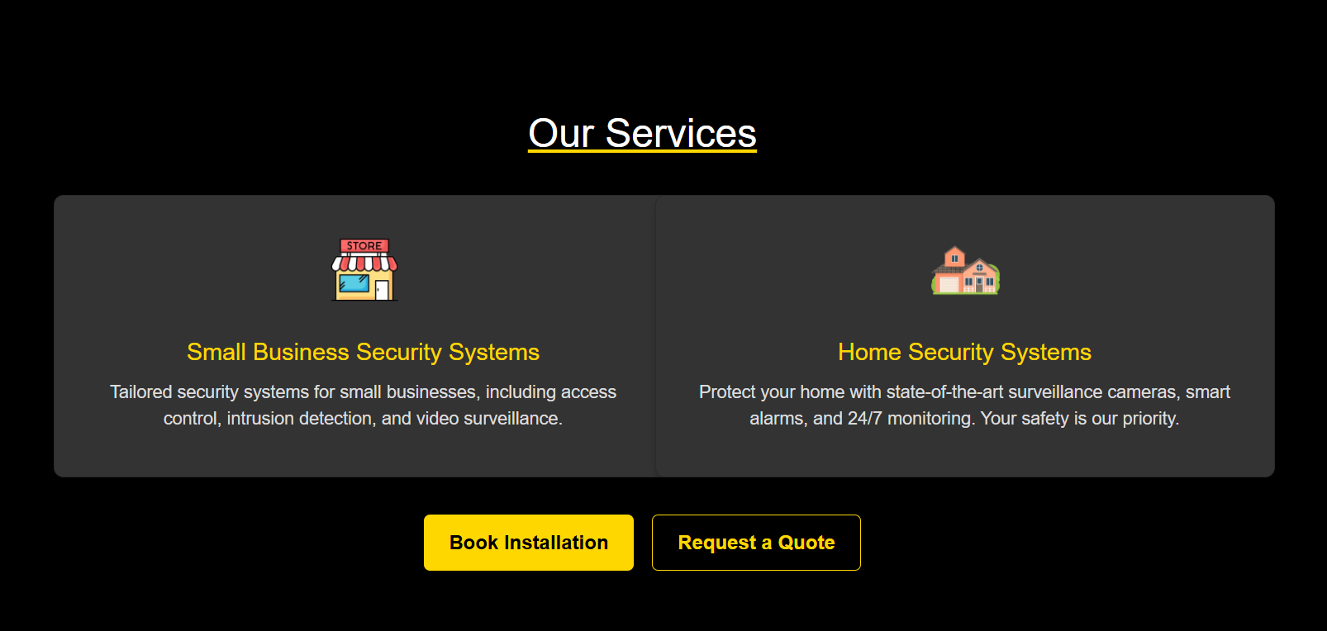

The two buttons at the services page weren’t working but I fixed them



This is the old footer the end-user gave me a feedback about changing the colors



This is the new footer after the changes .



Another feedback that it would be better to have a gap between the two cards

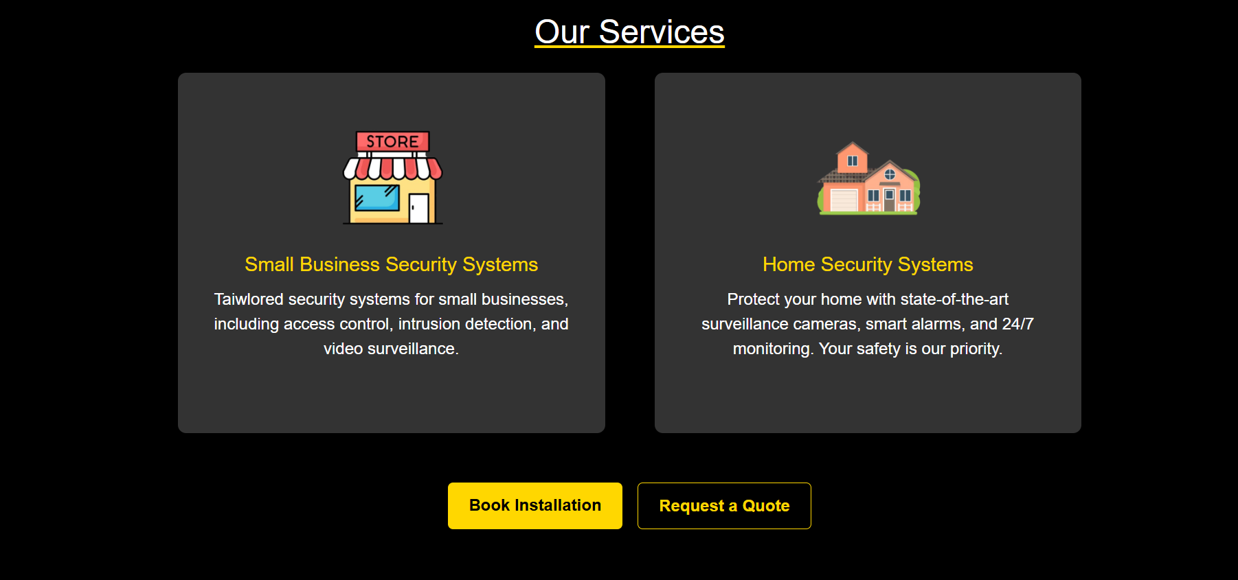

1. **Justification of design decisions :**

The new footer looks more modern good looking than the old one and the services is now more responsive and it looks better